Reminders for critiques!
Etiquette :
- Be helpful, your intention should always be to improve the photo
- Be respectful, keep your criticism phrased positively, this process should never involve insulting others.
- Be open to the feedback of others, be willing to revisit and even correct your photos.

Emotions:
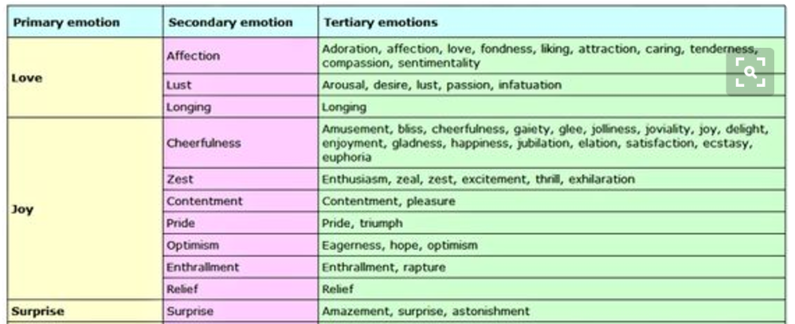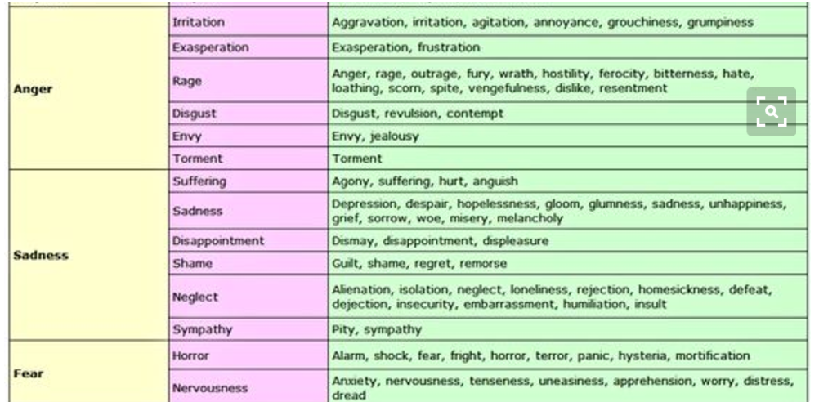

Common Rules of composition:
