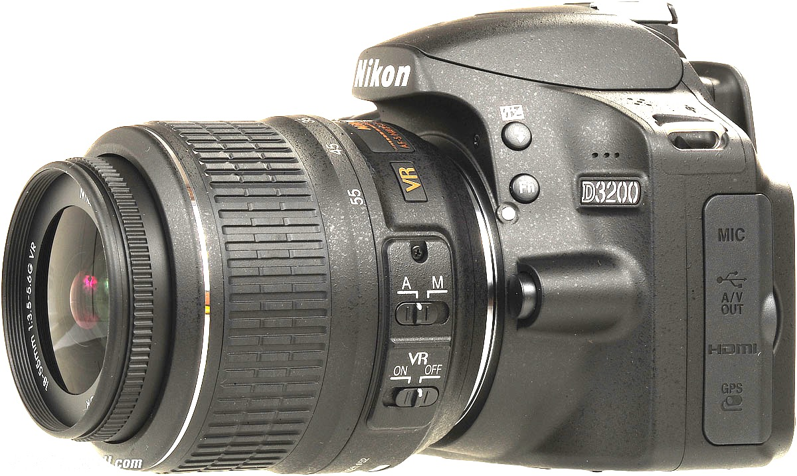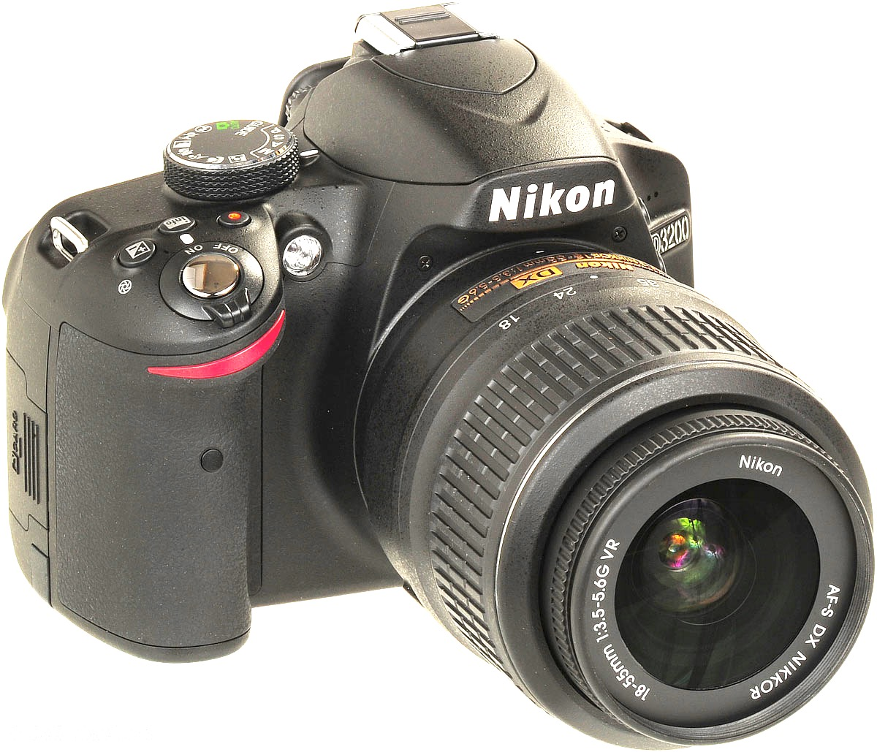

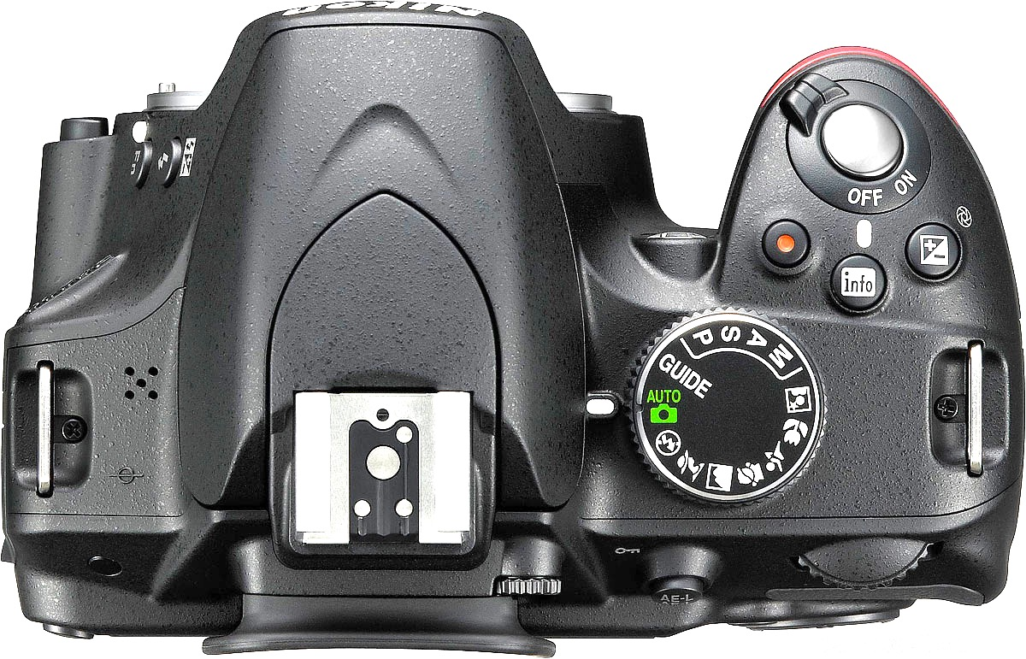

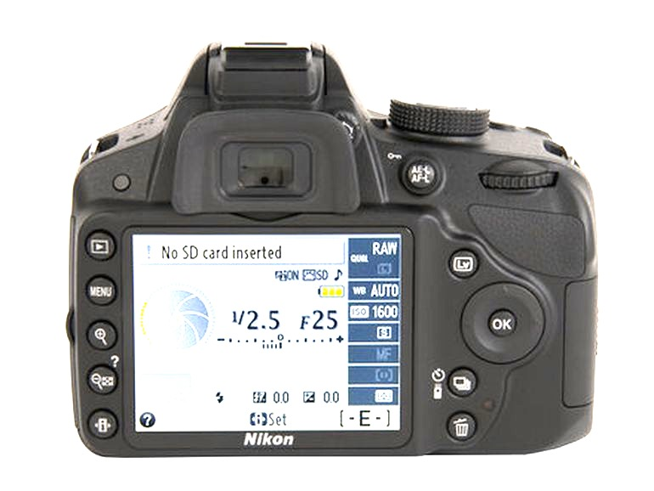
Camera Terms

Auto Focus & Manual Focus
Lens
Flash
Hot Shoe
Shutter Release
Mode Dial
Viewfinder
Shutter & Aperture Dial
Viewfinder to Screen Switch
View Images
Menu
Information (change ISO in here)
Trash
Screen

Aperture Questions:

Aperture controls the ___________________ of light and __________________ of ________________.

You just got to the top of the mountain and want to take a photo of the amazing view. Which aperture would be best?

A. f4.5
B. f8
C. f22

You are ditching class and hanging out at City Park. You see a cool bug that has the most interesting patterns on its back. Which aperture is best?

- f4.5
- F8
- C. f22

