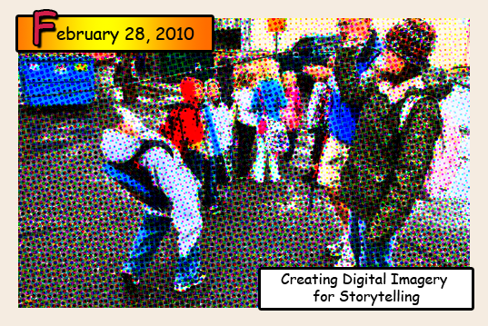

Creating the comic book feel

Photoshop or similar programs that can be downloaded or found on line can be used to give photograhps a comic book feel. If you don’t have access to Photoshop (PS) I will list a few popular image editing programs that can do similar effects to PS (at little or no cost) at the end of this tutorial.

Before opening Photoshop
1. Put 3-5 images on to the computer’s desktop. Choose photos that have a variety of “shots:” close-up, medium shot, long shot. This adds variety to your page and is crucial to telling a story in an interesting visual way.

Creating the comic panel page

1. In PS, open a new 8 ½ x 11 inch page. File>new In “preset choose” “US paper” Make your resolution 100 to 150 ppi (pixels per inch). SAVE the file as “comic page”

2. Open your 3-5 images into PS. File>open choose the desktop on the left and your specific photo on the right. Each photo will open into its own tab in PS.

3. Now we are going to copy each photo into a new layer on our comic page. Start with one of your photos and select it: Ctrl A. Now copy the image: Ctrl C and click on the tab for your comic page and pate the photo onto the page: Ctrl V. Or you can use the Edit menu at the top of the screen to select, copy and paste.

4. Resize your image: Ctrl T. Hold down the shift key (to keep the proportions) and use the corner squares to adjust the size. YOU MUST HIT ENTER to finish the transformation.

5. Using the move tool (the arrow-like key at the top of the tools menu) move your image into place on the page.

6. Using the same procedure (steps 3-5) copy, paste and resize all your images onto your comic page so that there is a nice border around the outside edge and even borders on the inside. You can use guidelines by clicking Ctrl R (rulers) and pulling blue guidelines over or down onto the page.

Now for the fun part!

Now we are going to start adding different techniques to the original photos still open in your tabs so that you can see which technique you want to use on your comic page. Here are a few good comic-style ones that are easy to do.

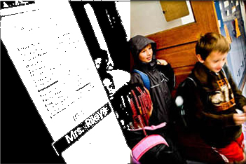
High Contrast: This is pretty much like how we treated our photos in Illustrator at our last session but the edges are not quite as smooth.

Along the top: Image>Adjustments>threshold. This will instantly turn your image into a high contrast black and white. You can adjust the slider right and left to get the image how you like it.

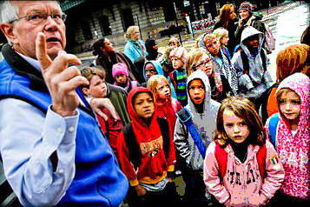
Posterize: This reduces the color down to however many steps you specify. The default 4 colors looks pretty good but play with different levels to see how they affect the photo.

Along the top: Image>Adjustments>Posterize.

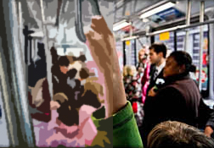
Cutout: This filter makes the image look like it was cut out of paper. It is a real graphic effect that works well for comics.

Along the top: Filter>Artistic>Cutout. On the right side of the panel adjust the levels and the edge simplicity sliders until you get the effect you like.

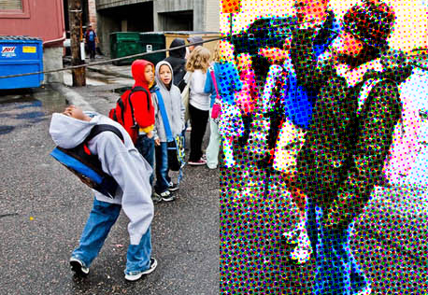
Enlarged Halftone Dots: This filter makes the image look like it was made from halftone dots (like Lichtenstein!). This takes the most steps but is well worth the time.

- Increase the overall contrast of the image. Image>Adjustments>Levels. Move the left slider slightly to the right and the right one to the left. Click OK.
- Now make the image grainy.
Go to Filters>Artistic>Film grain and use these settings: Grain, 4; Highlight Area, 0; Intensity, 10. Try different settings too just to see what they do.
- Duplicate the layer by right clicking on the layer and choosing duplicate. When the new layer dialog box pops up name it “halftone”
- Now apply a halftone pattern to the image. Filter>Pixelate>Color halftone. Set Max Radius, 4; and leave the rest with the default values. Press OK.
- Go to the layers palette and set the Blending mode to “Darken.” The Blending Modes are found in a rectangle at the top of the layers palette.

Apply the technique you like best to your comic page.

Go back to your page and do the effect you like best to all your photos.

Now add a border to each photo. Double click on the layer of the image you want to border. A menu box will pop up. Check the stroke box at the bottom and click to the right of the word “Stroke.” This will bring up the Stroke controls. Make the stroke width 3-5 pixels, change the color to black and click OK. You can copy the layer style on one layer and copy it to the other layers. Right click on layer, choose “paste layer style,” go to another layer, right click and choose “paste layer style.” In this way you can add a border to each image on your page.

Add speech and thought bubbles

Using the vector shapes box on the left, choose custom. Go to the top of the page and choose the shape selector. You might have to click on the little arrow and choose thought and speech bubbles.
*Note: Create a new layer for these shapes and make sure the layer is near the top of the layer palate so that they can be seen.

Almost done! Now add text to your bubbles and a title and author/artist

The text tool is on the left tool bar near the bottom. You can change the font along the top. Comic sans is a good choice for this project. By double clicking on the text layer you can add a drop shadow, glow, or stroke, the same way you did when you added a border to the image.

