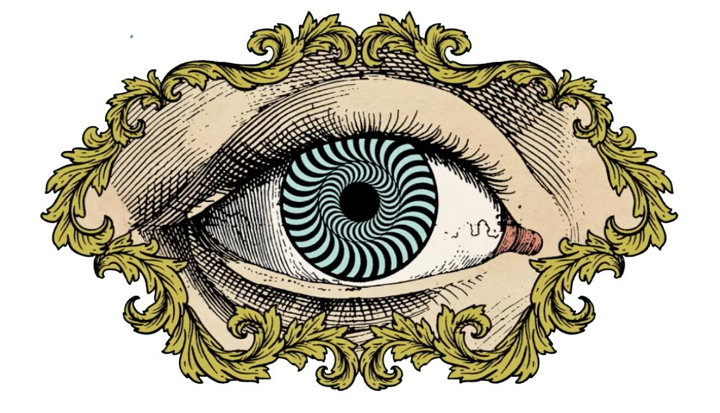
Vocabulary:

Illusion - An image that deceives a person, leading to a misinterpretation of its meaning.
Perception - The process of becoming aware through sight, sound, taste, smell, or touch; detection.
Perspective - The technique artists use to project an illusion of the three-dimensional world onto a two-dimensional surface. Fundamental techniques used to achieve perspective are: controlling variation between sizes of depicted subjects, overlapping some of them, and placing those that are on the depicted ground as lower when nearer and higher when deeper.
Scale - A ratio (proportion) used in determining the dimensional relationship between a representation to that which it represents (its actual size).
Forced Perspective - a technique that manipulates our human perception with the use of a camera lens to make objects appear larger, smaller, farther, or closer than they actually are.

2-3 Final Photos: Choose 2!

1) Forced Perspective: Distorting or creating a new reality: “Reality is simply a matter of perception”
- Mess with proportions of objects to create your own fantasy scene
- Always follow the rules of composition
- Use children’s books and movies as a reference for these photos

2) Perception: This photo should show a misconception in society that needs to be corrected. Example; putting work before your family
- What should be valued or fixed in society should be emphasized in someway (size, color, placement, etc)

3) Illusion: This photo should take on a challenging illusion in Photoshop (shown in class) AND convey a message about society’s perception.
- This is a combination of the two types above and should be attempted by students willing to challenge themselves.

Objective: To reveal a truth through Distorting reality!

Create an artwork that uses illusions for a specific purpose. Use feedback from peers, class critiques or teacher feedback to refine and solidify ideas.

Explain your purpose: _______________________________________________________
______________________________________________________________________
______________________________________________________________________
______________________________________________________________________
______________________________________________________________________

Thumbnail Sketches: Sketches that show the basic shape of the object in order to show how much space within the composition it will take. Use label if necessary. THESE ARE NOT DETAILED DRAWINGS

Major Photoshop edits used:
- _______________________________________________________
- _______________________________________________________
- _______________________________________________________
- _______________________________________________________
- _______________________________________________________
- _______________________________________________________

What feedback did you receive throughout the creation process that allowed your work to grow?
____________________________________________________________________________________________________________________________________________
PHOTO RUBRIC |  | Student | Teacher | Student’s reason for Score
Composition and Concept  - Photos each demonstrate a rule of compositional and has a strong focal point  - Photo shows the concept of Illusion |  | 1 2 3 4 5 | 1 2 3  4 5
Photoshop Requirements:  -Use of at least 1 Filter or blending mode  -Replace at least one background  -Follow 2 DIFFERENT rules of composition  - 1 New edit from the tutorials |  | 1 2 3  4 5 | 1 2 3  4 5
Artistic Requirements:  -At least 3 Sketches of Possible ideas  -Each Photo follows a different rule of composition  -Contact Sheet of 20+ images  -2 Final edited images-Approved by Ms. A.  ​  Written Requirements:  -Reflection fully filled out  -Final work posted on Weebly  -Summary of assignment is well written and includes academic language |  | 1 2 3  4 5  1 2 3  4 5 | 1 2 3  4 5  1 2 3  4 5

